<https://colab.research.google.com/drive/16c9bPF1I75JhTSZgStnAm8do4x7WhM5m?usp=drive_open#scrollTo=dsKqeDUxAZLJ>

import tensorflow as tf

from tensorflow import keras

import numpy as np

import matplotlib.pyplot as plt

fashion_mnist = keras.datasets.fashion_mnist

(train_images, train_labels), (test_images, test_labels) = fashion_mnist.load_data()

train_images.shape #(60000, 28, 28)

|  |  |
| --- | --- |
| #ver imagen 100  plt.figure()  plt.imshow(train_images[100])  plt.grid(True) |  |

train_images = train_images / 255.0

test_images = test_images / 255.0

%matplotlib inline

class_names = ['T-shirt/top', 'Trouser', 'Pullover', 'Dress', 'Coat', 'Sandal', 'Shirt', 'Sneaker', 'Bag', 'Ankle boot']

plt.figure(figsize = (10, 10))

for i in range(25):

  plt.subplot(5, 5, i + 1)

  plt.xticks([])

  plt.yticks([])

  plt.grid('off')

  plt.imshow(train_images[i], cmap = plt.cm.binary)

  plt.xlabel(class_names[train_labels[i]])

#Le asigna a cada imagen la etiqueta de que es

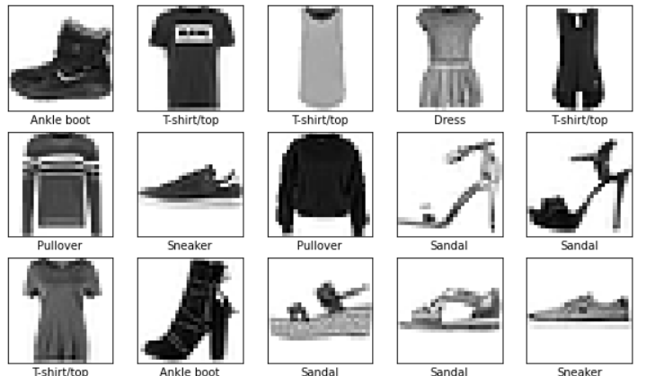

EXPLICACION

https://www.tensorflow.org/tutorials/keras/classification

[Fashion MNIST](https://github.com/zalandoresearch/fashion-mnist) dataset which contains 70,000 grayscale images in 10 categories. The images show individual articles of clothing at low resolution (28 by 28 pixels), as seen here:

|  |
| --- |
| Fashion MNIST sprite |